WORKFLOW AUTOMATION (EX-1)

Name: Ayush Kumar Burnwal
Register Number: RA2411056010256
Tool Used: Camunda Modeler
GitHub Repository: https://github.com/ayushb89/Workflow-Automation-
Scenario 1: Employee Leave Approval
Process description
An employee submits a leave request through the company’s HR system. The system first verifies the employee’s available leave balance. If sufficient balance is available, the request is forwarded to the manager for approval. Based on the manager’s decision, the system either deducts the leave from the employee’s balance and sends an approval notification, or sends a rejection notification. If the employee does not have enough leave balance, the system immediately sends an insufficient-balance notification without involving the manager. In all cases, the process ends once the appropriate notification has been sent.
Elements used :
1 Start Event: Employee submits a leave request.
6 Tasks:
- Check leave balance.
- Send request to the manager for approval.
- Update employee leave balance.
- Send approval notification.
- Send rejection notification.
- Send insufficient-balance notification.
2 Exclusive Gateways:
- Sufficient balance?
- Manager decision?
3 End Events:
- Leave approved.
- Leave rejected.
- Insufficient balance.
Each End Event represents one possible outcome of the leave request process.

Gateway logic
- Sufficient balance? — Yes: request goes to the manager. No: an insufficient-balance notification is sent and the process ends.
- Manager decision? — Approved: leave balance is updated and an approval notification is sent. Rejected: a rejection notification is sent.
Diagram

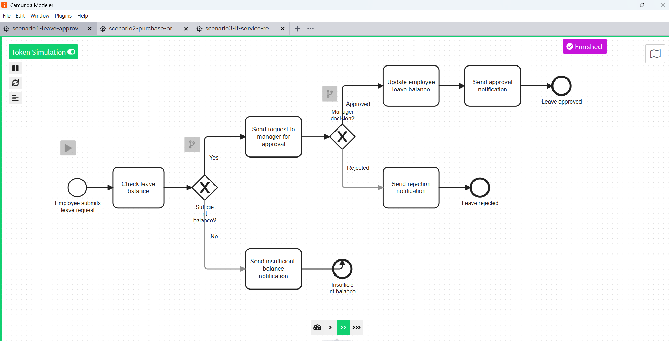
Figure 1: Employee Leave Approval process, model and simulated in Camunda Modeler.

Scenario 2: Online Purchase Order Processing
Process description
The process starts when a customer places an order. The system first verifies whether the product is available. If the product is out of stock, the customer is informed and the process ends. If the product is available, the system proceeds with payment processing. If the payment fails, a payment-failure notification is sent to the customer, and the process ends. If the payment is successful, the order is confirmed, the product is prepared and shipped, and a shipping confirmation is sent to the customer. The process then concludes.
Elements used
1 Start Event: Customer places an order.
8 Tasks:
- Check product availability.
- Notify customer that the product is out of stock.
- Process payment.
- Notify customer that the payment failed.
- Confirm the order.
- Prepare the product for shipment.
- Ship the order.
- Send shipping confirmation to the customer.
2 Exclusive Gateways:
- Product available?
- Payment successful?
3 End Events:
- Out of stock.
- Payment failure.
- Successful order completion.
The three End Events represent all possible outcomes of the order process.
Gateway logic
- Product available? — Unavailable: out-of-stock notification sent, process ends. Available: payment is processed.
- Payment successful? — Failed: payment-failure notification sent, process ends. Success: order is confirmed, prepared, shipped, and a shipping confirmation is sent.
Diagram
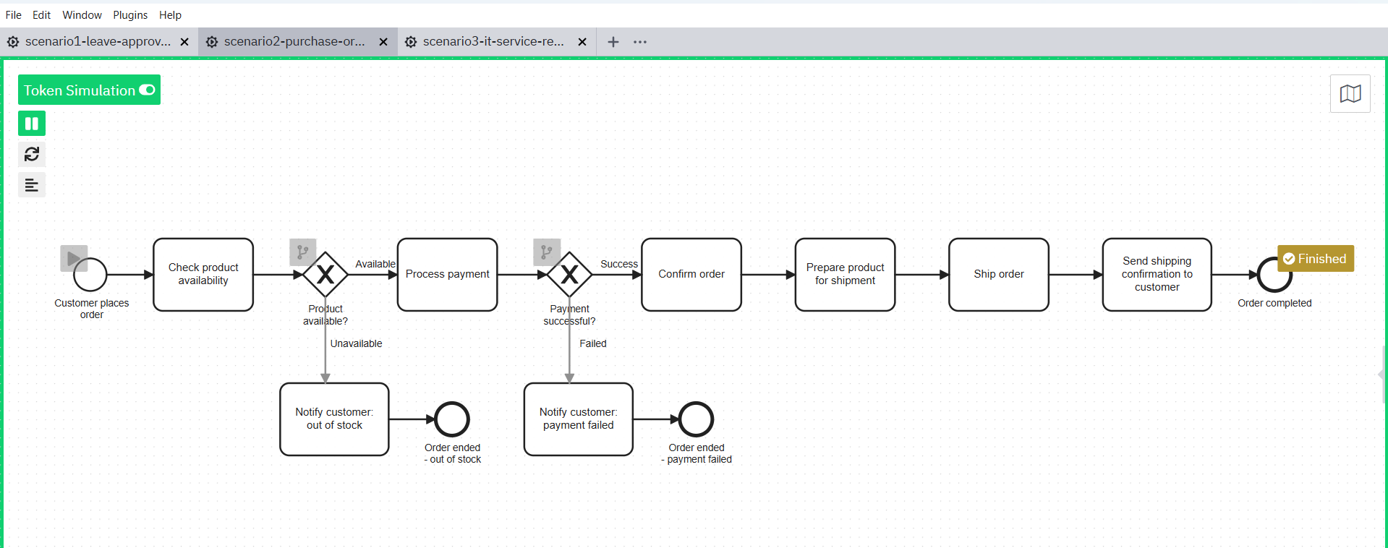
Figure 2: Online Purchase Order Processing, showing the multiple process paths and their end events.

Scenario 3: IT Service Request
Process description
The process begins when an employee reports an IT issue and submits a support request. The IT help desk records the request and evaluates its severity. Low-severity issues are assigned to a support technician, while high-severity issues are escalated to a senior technician. The assigned technician then investigates the problem. If the issue can be resolved internally, the technician fixes it; otherwise, the issue is escalated to an external service provider. Once the issue is resolved, the help desk updates the request status and sends a resolution notification to the employee. The process then ends.
Elements used
- 1 Start Event: Employee reports an IT problem.
- 10 Tasks:
  - Submit IT support request.
  - Register the request.
  - Check the severity of the problem.
  - Assign the request to a support technician.
  - Assign the request to a senior technician.
  - Investigate the problem.
  - Fix the problem.
  - Escalate to an external service provider.
  - Update the request status.
  - Send a resolution notification to the employee.
- 2 Exclusive Gateways:
  - Severity level?
  - Can the problem be resolved internally?
- 1 End Event: Request resolved.
- The severity-based branches and resolution paths eventually merge back into a shared task, demonstrating alternative paths that reconnect to the main process flow.
Gateway logic
- Severity level? — Low severity: assigned to a support technician. High severity: assigned to a senior technician. Both paths converge at "Investigate the problem."
- Can be resolved internally? — Yes: the technician fixes the problem directly. No: it is escalated to the external service provider. Both paths converge at "Update request status."
Diagram
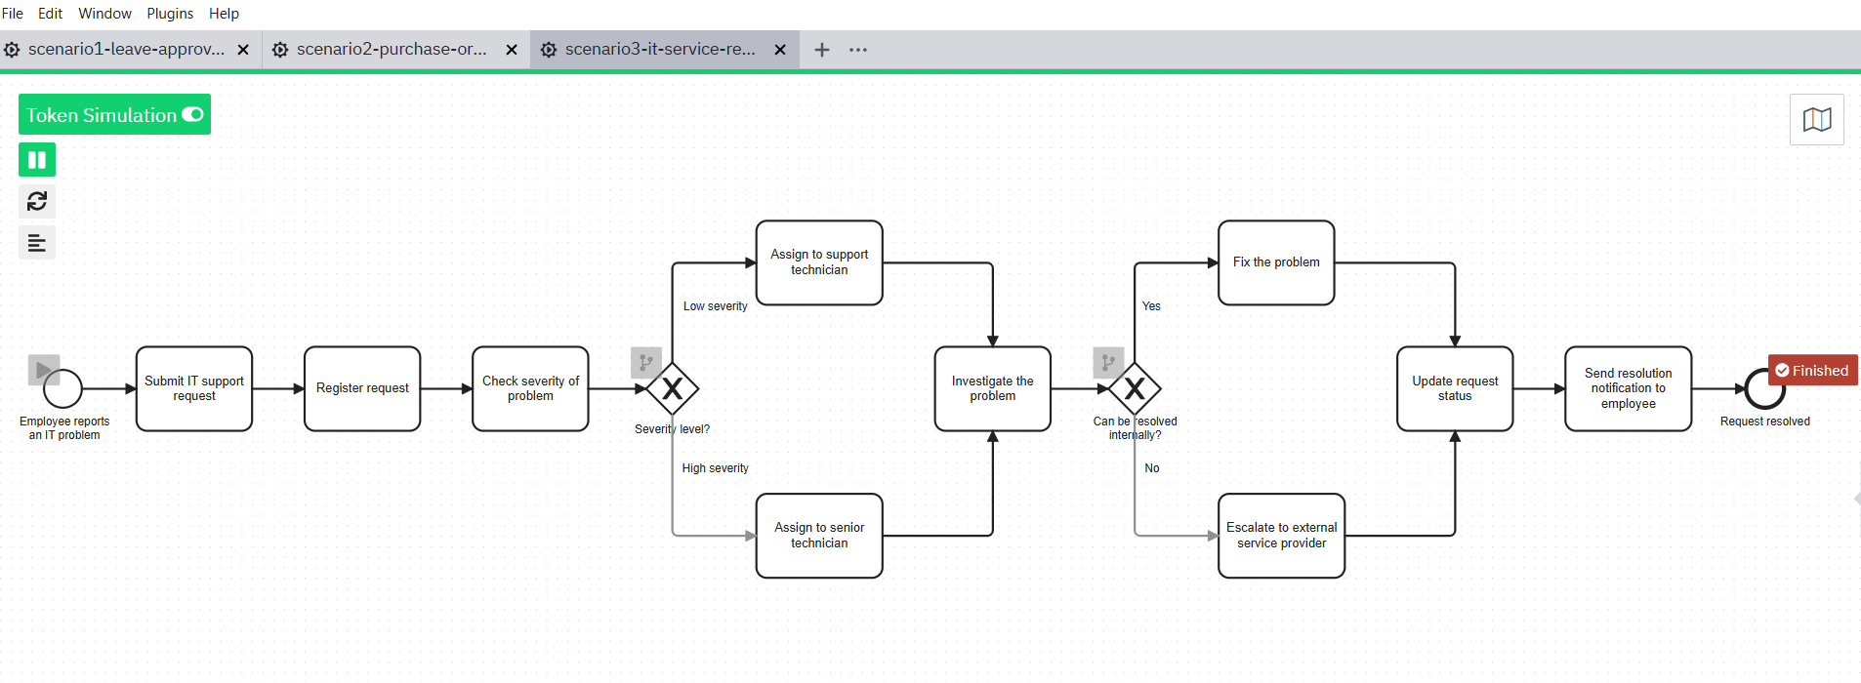
Figure 3: IT Service Request process, with severity-based and resolution-based alternative paths.

